 | DARTFORD, GRAVESHAM AND SWANLEY
Organisation | Services | Contact
Community Link Service  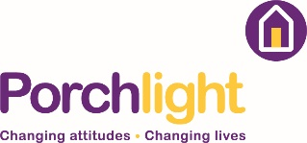 | Support and advice on where to get help  One to one telephone support or WhatsApp video calls  Support with  - housing, debt and benefits including online support  - support with wellbeing at this difficult time  - liaising with key agencies on clients’ behalf  - linking to community help and food parcels  Provision of a mobile phone for clients if they do not have access to one | Live Well Kent  0800 567 7966  info@livewellkent.org.uk
North Kent Mind  Wellbeing Services  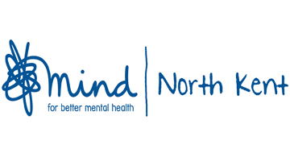 | Support and activities to promote good mental health and wellbeing  Regular contact by telephone and email or by post  Student social workers support clients with complex needs  In addition North Kent Mind are offering:  - Ecology Island digital quiz  - Service user film about keeping well  - Coping with Life courses online using Zoom  - Young people’s online “drop-in” managed by staff  - Young people’s online “how to be active”  - How to manage anxiety, stress and depression  - How to have a routine, practice mindfulness and coping strategies  - Information about local support  - Links to audio mindfulness  - Activities during isolation  IAPT NHS Free talking therapies  - Facilitated over the telephone  - Silvercloud self-guided online help at https://northkentmind.silvercloudhealth.com/signup/ | admin@northkentmind.co.uk  01322 291380
Invicta Health Care | Primary Care Mental Health Specialist service for patients in primary care with mental health needs including depression, anxiety and mood disorders  Referrals can be made by GPs and other organisations including Live Well Kent, NHS talking therapies and Community Mental Health teams.  Staff are trained to help understand, cope with and overcome mental health and emotional problems and offer:  - a full mental health assessment  - treatment plan  - short term follow up  - referrals to Community Mental Health teams, NHS talking therapies or Live Well Kent  Telephone review for existing patients, ongoing support by phone or video. New patients screened within 48 hours and first assessments by phone. Patients are seen in clinical settings or at home in exceptional circumstances only. | invictahealth.mentalhealthreferrals@nhs.net  0800 242 5199 (option 1)
Rethink Sahayak | Rethink Sahayak services is a BAME (black and minority ethnic) service  One to one support by telephone  Sangam group – peer support through one to one phone support on a weekly basis  - to explain NHS guidelines for the covid19 pandemic  - to make sure members complete exercises like walking or a simple work out at home  - to encourage healthy eating  - to hobbies such as the knitting initiative.  The Asian mental health helpline is open for emotional support  - Mon and Weds 4pm -7pm  - Tues and Thurs 12pm – 3pm  The Gurdwara Management committee has created a “langar delivery sewa” team that will deliver langar (blessed food) to those who fall within the vulnerable status and require food because they are unable to obtain food or don’t have access to family and friends that are able to help. Access to the service is through online referral or by telephone | 01474 364837  01474 364498  sangamgroup@rethink.org  Asian Mental Health Helpline  08080 800 2073  Guru Nanak Darbar Gurdwara  01474 761063  www.gurunanakdarbar.org/langar-delivery
Community Inclusion Service | Support for people who are socially isolated  One to one telephone support around feeling socially isolated, feeling lonely and or anxious.  WhatsApp video calls to keep connected if technology allows  - small groups and activities via Zoom  - promoting wellbeing  - liaising with key agencies on clients’ behalf  - linking to community help and food parcels  Provision of a mobile phone for clients if they do not have access to one | Live Well Kent  0800 567 7966  info@livewellkent.org.uk
Community Housing Service | Support for people with housing and mental health issues  One to one telephone support around people’s housing situation and mental health  WhatsApp video calls to keep connected if technology allows  - liaising with local authorities  - liaising with housing associations and private landlords on clients’ behalf  - finding appropriate legal advice if required  Provision of a mobile phone for clients if they do not have access to one | Live Well Kent  0800 567 7966  info@livewellkent.org.uk
Invicta Health Care | Primary Care Mental Health Specialist service for patients in primary care with mental health needs including depression, anxiety and mood disorders  Referrals can be made by GPs and other organisations including Live Well Kent, NHS talking therapies and Community Mental Health teams.  Staff are trained to help understand, cope with and overcome mental health and emotional problems and offer:  - a full mental health assessment  - treatment plan  - short term follow up  - referrals to Community Mental Health teams, NHS talking therapies or Live Well Kent  Telephone review for existing patients, ongoing support by phone or video. New patients screened within 48 hours and first assessments by phone. Patients are seen in clinical settings or at home in exceptional circumstances only. | invictahealth.mentalhealthreferrals@nhs.net  0800 242 5199 (option 1)
North Kent Mind  Springboard Employment Service  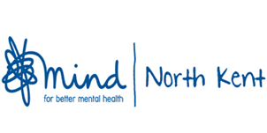 | Support into employment  Springboard offers a full service by telephone including  - ongoing support  - signing up new registrations  - job searching  - emails of vacancies  - CVs and mock interviews  - Advice/guidance  - Online courses | admin@northkentmind.co.uk  01322 291380
Megan CIC - Personality Disorder Peer Support  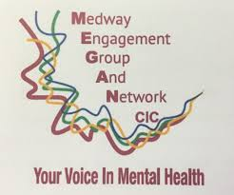 | Personality disorder peer support  One to one support by telephone for clients with personality disorder  Weekly contact with clients  Personality disorder peer support group weekly check ins  Peer support through the Megan CIC Facebook page | enquiries@megancic.org.uk  01634 402077
Rethink Asian Mental Health Helpline | A free and confidential Asian Mental Health helpline  offering caring, non judgemental and empathetic support covering mental health and domestic abuse issues.  You can speak to us in Asian languages (Gujarati, Punjabi, Hindu, and Urdu) or in English.  - Mondays and Wednesdays 4pm to 7pm  - Tuesdays and Thursdays 12pm to 3pm | 0808 800 2073
SpeakUp CIC  Night Owls | Night Owls – Support for people who are finding it difficult to sleep  It is a closed moderated Facebook group for people who are awake at night and want to  - post in a safe place  - see if anyone else is awake and up for a chat  Night Owls site is especially valued during this difficult period | Maggie Gallant  Maggie@speakupcic.co.uk.  Kay Byatt  Kay@speakupcic.co.uk  07543 977670

